PIT Tags

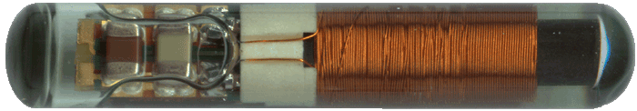
Photo: Oregon RFID
Keeping tabs on individual wild animals is a difficult task, but one that is critical if scientists are to determine important information such as movement patterns, growth and survival rates. Methods such as leg bands, radio collars, tattoos, paint, clipping fins and drilling shells have been used with a range of success. For animals with no appendages, however, finding a place to mark is difficult. External tags or bands can interfere with the animal’s habits or make it easier for predators to spot or catch. And normal activities such as burrowing and molting can dislodge external hardware.
Click to see video of a microchip being implanted in a parrot.

Beginning in the mid-1980s, tiny electronic markers called passive integrated transponders or PIT tags have been used successfully to accomplish animal tracking without the drawbacks of external devices. Pet owners and zoos can implant the tags to aid in identification, as well. Using PIT tags has given scientists a greater understanding of social interactions among individuals in a population, according to Dr. Whit Gibbons, a professor of ecology at the University of Georgia Savannah River Ecology Laboratory. He says, “PIT tags offer many opportunities to unravel animal mysteries that heretofore could not be addressed effectively.” "PIT tags have made identification a lot easier," said Tracy Lynch, a former research technician at SREL. "There is much less error involved.”
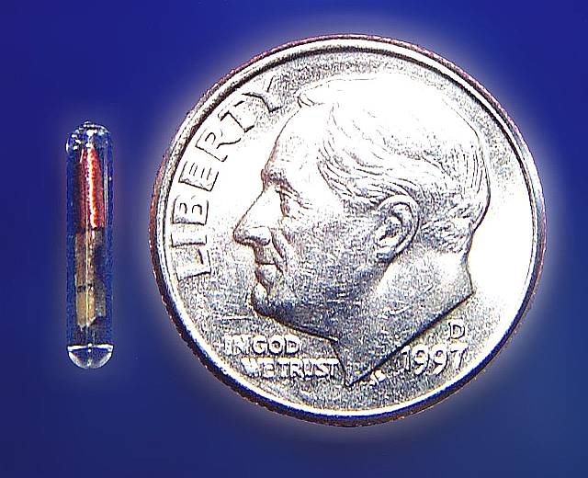
A PIT tag is encased in glass that protects the electronic components and prevents tissue irritation in the animal. Inserted with a 12-gauge needle or by surgical incision under the animal’s skin, they serve as a permanent coded marker that is a reliable form of identification of an individual. The tag is activated by a handheld reader which generates a close-range, electromagnetic field. The tag is activated and transmits its number to the reader. This unique alphanumeric code permits a tagged individual to be distinguished from every other one, whether on a population or global scale. The process is similar to scanning bar codes in a grocery store.
PIT tags do have their drawbacks: cost, low detection distance, and potential tag loss in some circumstances. One such loss at the Savannah River Ecology Laboratory actually ended up unintentionally documenting a hypothesis. When a field biologist at SREL held a scanner to an eastern kingsnake, the number code revealed information no one had anticipated. The biologist had caught the big kingsnake and was preparing to give it a unique code before returning it to the capture site. He discovered that the kingsnake already had an identification code inside its body--one belonging to a black swamp snake. In this case PIT tagging documented that eastern kingsnakes are predators of black swamp snakes.
Source: http://www.biomark.com/river-systems.htm
FAQ – reprinted with permission from Biomark
What is a PIT tag?
A Passive Integrated Transponder tag is a radio frequency device that transmits a unique individual code to a reader where it is displayed in a numeric or alphanumeric form. The tag has no internal battery, hence the term “passive". The reader powers or excites the tag circuitry by radio frequency induction and receives the code back from the tag. Radio frequency identification (RFID) does not require line of sight, tags can be read as long as they are within the range of a reader.
What materials can a PIT tag be read through?
Tags can be detected through materials like plastics, water, wood products, animal tissue and bone, fabrics, fiberglass, rock and most nonferrous metals.
How small an animal can be tagged?

The size of an animal to be tagged using PIT tags varies and depends on the species. Fish less than 55-mm have been successfully tagged using the small 11.5-mm tags. These tags weigh about 0.1 grams. Small mice, frogs and salamanders have also been tagged with good success for years.
Where is the best place to implant a tag?
The implant site is dependent upon the species, size of the animal and the size of the tag.
How long will a PIT tag last?
Design engineers' calculations suggest that PIT tags can last as long as 75 years or more. There is no battery to fail and the glass encapsulation is impervious to almost everything. PIT tags can be removed or recovered from a primary location and reused indefinitely.
Associated Humane Societies
Will the animal's survival be affected by the implantable tag?
Many studies have addressed this subject and there is virtually no negative impact on animals provided they have sufficient body size and behavior is not inhibited by the tag. Strict protocols are followed to minimize animal discomfort during tagging and maximize survival afterwards.
What kind of equipment is used?
See Biomark’s online catalog at http://www.biomark.com/river-systems.htm
What animals have tags been used on?
Small Selection of RFID Tagged Animals :
Bass, Bats. Bears, Beavers, Birds, Bobcats, Brook Trout, Bison, Bull Trout, Camels, Catfish, Chinook salmon, Cichlids, Crayfish, Cutthroat Trout, Deer, Elk, Fishers, Flounder, Flying Squirrels, Fox Squirrels, Fox, Frogs, Gopher, Tortoise, Grayling, Kangaroo Rats, Lamprey, Martin, Mice, Modoc Suckers, Muskellunge, Otters, Pallid Sturgeon, Perch, Possums, Pygmy Rabbits, Quail, Raccoons, Rattle Snakes, Salamanders, Sea Lamprey,Sea Turtles, Sea Urchins, Seals, Sharks, Skunks, Snook, Sockeye Salmon, Spotted Skunks, Steelhead, Sturgeon, Suckers, Sunfish, Toads, Trout, Turkeys, Turtles, Walleye, Weasels, Whitefish, Wolves, Wood Rats

Source: http://www.biomark.com/river-systems.htm

Interesting article about commercial applications for RFID technology can be found on the RFID Journal website.
Want To Know More?
PTAGIS Interpretive Center
Pit Tag Information System (about pit-tagged fish in the Columbia River Basin) Provides an excellent interactive tutorial about tagging of fish in the CRB. http://www.ptagis.org/
The site includes step-by-step photos of the tagging process, as well as information about precautions taken to protect the fish from harm. The end of the tutorial has links to a 27-minute video of best practices in tagging and a 12-minute video about how PIT-tagged fish are detected at large hydroelectric dams. Access to data sets is provided through links, or go to www.ptagis.org/ptagis

Online Data
Columbia River DART (Data Access in Real Time) http://www.cbr.washington.edu/dart/dart.html
Fish passage and PIT tag data updated daily. Also has links to River and Ocean hydrology and water quality data

Are Fish Harmed by the Tagging Procedure?
“An Assessment of Freeze-brand and PIT-tag recovery data for juvenile salmonids at McNary Dam, 4-90. This study evaluated mark recovery data from PIT-tagged and freeze-branded rover-run yearling and subyearling chinook salmon, sockeye salmon, and steelhead at McNary Dam in 1988. Double-marked (PIT- tagged and freeze-branded) juvenile salmonids were released within the McNary Dam collection system upstream from the PIT-tag detectors and brand sampling system. Results indicate that brands were recovered in smaller proportions than PIT tags and the variability of brand data was considerable. Most of the error associated with brands was attributable to human error inherent in brand detection and interpretation
Report by the Pacific Salmon Commission, February 2006

At one time in the 1980s, PIT tags were soaked in a red dye to easily reveal broken tags and prevent implantation of defective units. That dye was found to be lethal to fish and has subsequently been replaced with one that is not.

A 1991 study was undertaken to determine whether the electromagnetic field created by the scanners was harmful to the fish or their offspring and concluded that ” There were no significant differences between control and EMF-exposed treatments in any category (e.g., egg production/female, fertilization rates, larval mortality rates, deformity rates, overall survival) in exposures up to 24 hours.

A 1986-87 study of PIT tags in fish by the National Marine Fisheries Service concluded that “Laboratory studies with juvenile Chinook salmon showed that retention of glass-encapsulated PIT tags was 99-100% in fish weighing 3 g (mean weight) or larger. No adverse tissue response to the tag was noted. The survival of fish 5 g (mean weight) or larger was usually greater than 99%. However, fish ranging in weight from 2 to 4 g, or fish undergoing a physiological change such as smoltification may have a low mortality (usually less then 5.0%) after tagging. The mortality rate in the smaller fish was dependent upon tagging skill whereas mortality in smolting fish seemed dependent upon the level of stress. Growth comparisons between tagged and control fish indicated PIT-tagged fish had a slightly depressed growth rate at some measurement periods. The operational life of glass-encapsulated PIT tags implanted in fish was good, with 100% of the tags operating after 401 days. No tags were rejected from the fish during the observation period.”

http://www.psc.org/pubs/SFEC06-1.pdf
http://pisces.bpa.gov/release/documents/documentviewer.aspx?pub=D11982-6.pdf
http://pisces.bpa.gov/release/documents/documentviewer.aspx?pub=D11982-3.pdf

