Individual Watershed Models

Purpose: This activity allows students to demonstrate their understanding of watersheds by constructing a simple model.

Method: Students gain an intuitive knowledge of the physical aspects of watersheds by
creating their own watershed models.

Materials:
- One 8.5” x 11” sheet of paper per student, preferably graph paper
- One sheet of cardboard or tag board per student. The dimensions of this sheet should approximate 8.5” x 11”, but do not have to be precise.
- Water-soluble, non-permanent felt markers in a number of colors, two markers per student. The best colors are dark colors, such as black, brown, purple, blue and green. It might be best for each student to have at least one blue marker.
- Spray bottles with tap water in them. (You may want to have only one available or one per adult.)
- Scotch tape, one for every two students
- (Desirable, but not necessary) Plastic and shaded paper relief maps, topographic, and flat maps.

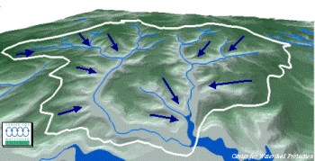
Background: The term watershed describes an area of land that drains downslope to the lowest point. The water moves through a network of drainage pathways, both underground and on the surface. Generally, these pathways converge into streams and rivers, which become progressively larger as the water moves on downstream, eventually reaching an estuary and the ocean. Other terms used interchangeably with watershed include drainage basin or catchment basin.
Figure 1 from Center For Watershed Protection
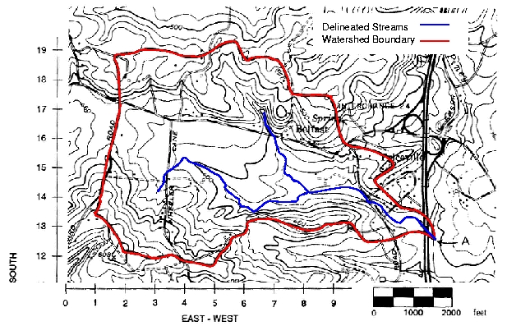
Watersheds can be large or small. Every stream, tributary, or river has an associated watershed, and small watersheds join to become larger watersheds. It is relatively easy to delineate watersheds using a topographic map that shows stream channels. Watershed boundaries follow major ridgelines around channels and meet at the bottom, where water flows out of the watershed, a point commonly referred to as a stream or river.
Figure 2 Dr. T. Brikowski, Geosciences Dept., UTD

Defining a watershed in a classroom is one thing, but intuitively appreciating the reality of a watershed is quite another. Watersheds are best studied by being out in them. Even beyond that is the problem that watersheds are generally very large, on a scale bigger than humans usually think. Finally, unlike other large geological features such as mountains, they are difficult to see unless you are above them. This activity provides students in the classroom a more approachable perspective of watersheds by having them make simple models.

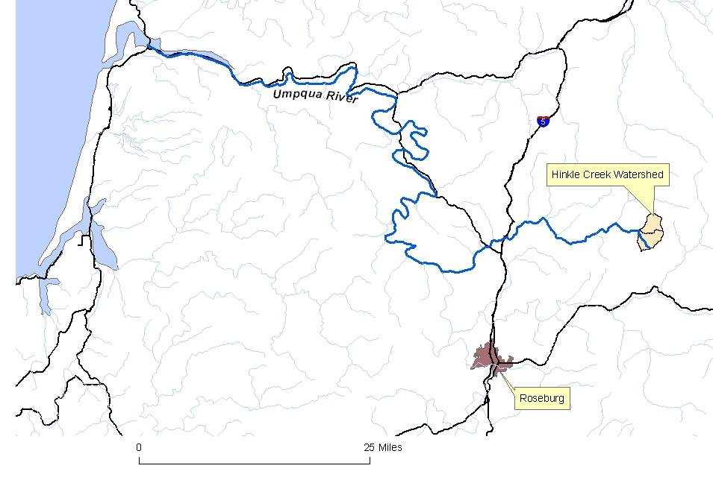
The Hinkle Creek study is significant because it is a paired watershed study. In order to state with confidence that the results found in the experimental side are due to timber harvest activities, scientists use a similar site that is left undisturbed.

Procedure:
- Discuss the differences between a flat map, topographical map, and relief map. Students will be making a relief map.
- Take a sheet of paper and crumple it up into a wad. The tighter the crumpling, the more complex the watershed modeling.
- Uncrumple the paper and set it on the sheet of cardboard. Tape the edges of the paper onto the cardboard base, leaving about an inch of cardboard exposed around the perimeter. This will create a miniature landscape of mountains and valleys. Ask the students to identify the tallest mountain or the deepest canyon. Have them inspect their landscape from above and show them an example of a true plastic relief map and/or a shaded relief map. Have them look at their landscape from the side as if they were on a nearby plain looking up at the mountains. There are many geographical or landform terms that can be introduced or reviewed as appropriate to your grade level.
- (You may want to model this step before having students proceed). Using a dark-color felt marker, other than blue, and gently trace the tops of the “mountain” ridges and divides. This may take awhile. Encourage the students to carefully follow ridges as far as they go and to the edge of the tape if necessary. Take the time to explain that ridges define the boundaries of watersheds. Also have them look at their landscape from above and notice that some watersheds are entirely encircled by ridges, “closed watersheds,” and some are open to the edge of the paper, “open watersheds.” Careful observation will also show that big watersheds are made up of smaller watersheds. Some terms to discuss include: mountain pass, divide, saddle.
- Ask the students to select another color marker, preferably blue, and carefully draw where they think the rivers and lakes would be in their valleys. This can be tricky if their crumple patterns are too complicated or too narrow for the felt markers to fit. This requires some imagination and careful observation of the folds and elevation changes of the paper. For rivers, it is easiest to start at the bottom of a valley and follow it uphill. If there are valleys where they can not go “down” any further, that may be a place to draw a lake. Lakes can be drawn in little bowls on hillsides or at the bottom of long valleys with ridges at both ends. Although watersheds are defined by the ridges, they are named by the rivers and streams. Have students write their names on the bottom of the cardboard before the next step.
- Now tell the students that it is time to test how good they were at predicting the paths of the rivers. Take the spray bottle and simulate rain by misting the paper watershed while it is flat on a counter. Don’t spray directly on the paper, but have the droplets fall on the paper. Have students observe as the water seeps down-hill through the paper. You can make different effects by adjusting how wet you make the paper. If you spray the paper heavily, actual drops will run down the sides of the paper and pool into “lakes.”
Figure 3 Southwest Florida’s Watershed Excursions
- Let the paper watersheds dry. The paper will become even more colorful as the dark inks slowly separate into a rainbow of colors.
- Once the models are dry (30 minutes or more), Have students determine whether they correctly predicted where the water would flow into rivers and lakes. Finish by asking them to again to define what a watershed is and with a new color or marker, have them outline one entire watershed.

Extensions or Variations:
Mapping the paper watersheds: Using graph paper, have each student render a two-dimensional map that represents their three-dimensional watersheds.
Have them decide on the scale of graph paper grid lines and then have them estimate:
- the lengths of the rivers
- the heights of the mountains
- the area of the valleys
- the volume of water that would enter the watershed if one inch of rain fell in one of those valleys.

Human activities: Add where people would build houses and recreation or industrial sites. On the lakeside? Near a creek? In the mountains? Why are different locations preferred? How would those sites be affected during heavy rains or flood events?

Information about watersheds is available on the Internet. To locate your watershed and get a profile of it, follow these steps:
- Go to the United States Environmental Protection Agency (EPA) Web site at http://cfpub.epa.gov/surf/locate/index.cfm
- Locate your watershed by entering your zip code in the space labeled “Your Entry.”
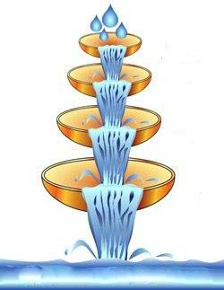
- Following links on the resulting page can lead you to data which students can use in lieu of gathering it themselves, such as this chart of water usage by Oregon.

Watersheds form a nested hierarchy. It is mainly topography that determines where and how water flows from one area to the next. However, each large drainage basin can be broken into smaller drainage basins called sub-watersheds. The flow of water (and whatever it carries with it) is influenced by large features such as continental divides, but one can also focus on drainage around an individual river. Thus, watersheds come in all shapes and sizes. This also means that each watershed has a sub-watershed. Using the link above, get a map of your watershed and have students identify sub-watersheds. Then create a graphic such as the one at right, labeling each part.
For More Information
Introduction to Watershed Ecology a 21-page interactive online tutorial that includes a self-scoring assessment at the end. http://www.epa.gov/watertrain/ecology/index.html
Tutorial goals:
- Introduce terms and concepts associated with watershed ecology.
- Describe typical watershed structure and how watersheds work, at different geographic scales and through time.
- Provide related examples of contemporary issues in watershed ecology
Water Science for Schools from the US Geological Survey (USGS) offers information on many aspects of water, along with pictures, data, maps, and an interactive center where you can give opinions and test your water knowledge. Website also available in Spanish.

Willamette Riverkeepers Water quality data sheets and protocols; various searchable databases. http://www.willamette-riverkeeper.org/programs/WQvol/WQvolResources.htm

Gunpowder Watershed Coalition

National Geophysical Data Center Use posted data to complete a water budget activity
Data Access Page

Simon Fraser University geography department.
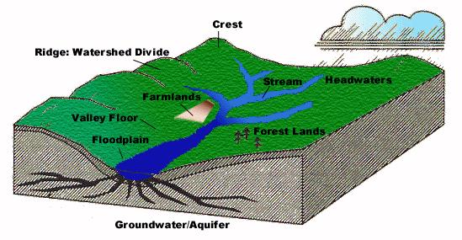
Basic hydrology tutorial

