Foundations:
Oregon Natural Resources Education Program (ONREP) Vision, Mission and Outcomes:
Vision-Students become environmentally literate citizens equipped to make informed decisions, exhibit responsible behavior, and take constructive action to ensure a sustainable future for Oregon’s natural resources.
Mission-Prepare educators to engage students in relevant, meaningful, and inspiring classroom and outdoor learning experiences that contribute to student academic achievement.
Outcomes-
- Educators use Oregon’s natural resources content in their teaching and seek additional opportunities to engage with ONREP.
- Educators engage students in actively learning about Oregon’s environment inside and outside the classroom using high-quality curriculum, strategies, tools and resources.
- Educators engage students in experiences that connect to their environment and community,…,projects that have a real-world application.
- Educators’ build and use network of support that enables them to integrate to use their understanding about Natural Resources in other contexts. Extend their learning and application.
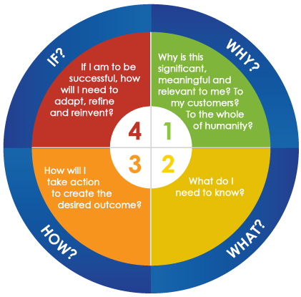
Learning Styles Model:

Notes to Facilitators:

Sequencing Possibilities (The order of events is up to you and the co-facilitator. Please arrange the workshop in a way that makes educational sense):
- AKCA model (Awareness, Knowledge, Challenge, and Action.)
- Performance Assessment Task Elements (Essential Question, Setting the Context, Building Background Knowledge, Student Task, Rubrics)
- Service Learning (Setting the Context, Investigation, Planning, Action, Reflections. Demonstration)

Checklist:
Did you include:

    - Introductions?
    - Guide familiarization?
    - Standards connection?
    - Work session for the educators?
    - OFRI and OFRI Resources?
    - Additional ONREP Workshops

An ONREP workshop should be a balance of activities, content delivered through resource professionals, networking, and familiarization of resources. If you have any questions or want more information about anything mentioned in this document please contact ONREP via LeeAnn.Mikkelson@oregonstate.edu
Please submit a draft to ONREP for review 6 weeks prior to the scheduled workshop. LeeAnn.mikkelson@oregonstate.edu. Call if you have any questions: 541-737-9121.
Name of Professional Development/Where
Date of PD
Facilitators
Professional Development Specific:
Goals:
- Goals are broad statements about intention that provide a framework for determining outcomes and objectives. They provide the “big picture” about what the PD intends to accomplish. Ex.: Students become environmentally literate.
Outcome(s):
- Outcomes define what the educators will be able to do in real time as a result if the program in which they are participating. Outcomes may have short or long term elements. Determining your outcome prior to developing an agenda will drive the knowledge, skills, and strategies you will include in your program. Ex.: Teachers engage their students in authentic outdoor field investigations as an integrated part of their teaching.
Objectives:
- Objectives define what educators actually do at the PD event that prepares them to meet the outcomes. Objectives are action and task oriented, specific and measurable. Ex.: Teachers will participate in a field investigation.

Focus Standards:
- If applicable, review the standards of the grade band that is marketed. Consider posting them here for easy reference.

 | Day and Date
 | Intent:  Who:  Time:  Materials:  - Sign-in sheet  - Objectives and Agenda  - Table supply bins  - Projector?  - Computer?  - All boxes  - All workshop materials | Room Set-up:  For example:  - Sign-in table with sign in sheet, name tags and markers  - Set up projector and computer and check to see that everything is working.(if needed)  - Set up tables and chairs to facilitate communication as a whole group and as small groups. There should be plenty a space to get up and move.  - Check the outdoor spaces for outdoor activities.  - Check the indoor spaces in case of inclement weather.  - Group workshop materials in an organized way.  - Put supply bins on each table.  - Post Goals, Outcomes, and Objectives and Agenda.  Facilitators’ Notes:  It is important to discuss roles and expectations before we start the workshop: recorder, timekeeper, trackers. Be sure to do this before we begin setting up.
 | Intent:  Who:  Time:  Materials:  - Nametags  - Registration list  - Highlighters  - Pencils and pens  - Participant Agendas | Registration:  Set up the registration table in a place that can greet and provide direction to participants as they come into the workshop space.  - Check people in  - Name tags  - Agendas
 | Intent:  Who:  Time:  Materials:  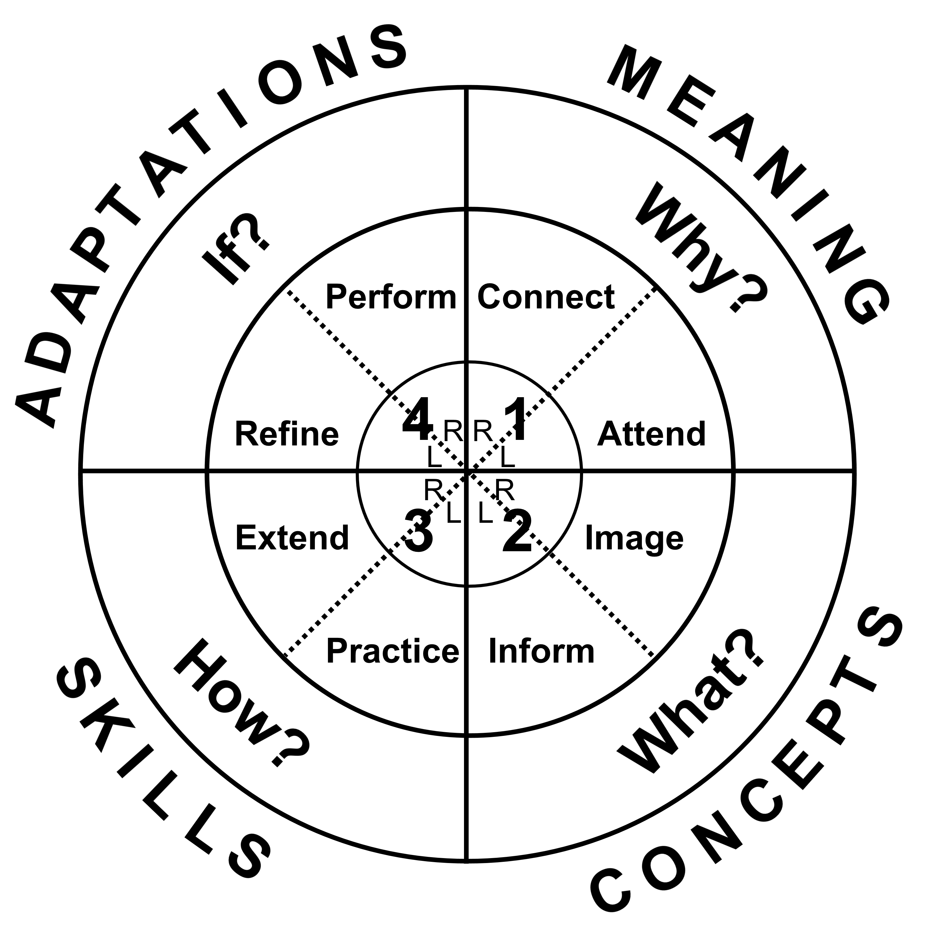  - materials | Hook Activity: Activity Title/Guide and page #  Set-up:  - This set up section is for steps to do to prepare the space for the activity.  Debrief:  Open:  Focus:  Interpretive:  Summary:  Facilitators’ Notes:  Special directions
 | Intent:  Who:  Time:  Materials:  - materials | Session/ Activity Title/Guide and page #  Set-up:  - This set up section is for steps to do to prepare the space for the activity.  Debrief:  Open:  Focus:  Interpretive:  Summary:  Facilitators’ Notes:  Special directions
 | Intent:  Who:  Time:  Materials:  - materials | Session/Activity Title/Guide and page #  Set-up:  - This set up section is for steps to do to prepare the space for the activity.  Debrief:  Open:  Focus:  Interpretive:  Summary:  Facilitators’ Notes:  Special directions
 | Break
 | Intent:  Who:  Time:  Materials:  - materials | Session/Activity Title/Guide and page #  Set-up:  - This set up section is for steps to do to prepare the space for the activity.  Debrief:  Open:  Focus:  Interpretive:  Summary:  Facilitators’ Notes:  Special directions
 | Lunch (45 minutes is usually adequate)
 | Intent:  Who:  Time:  Materials:  - materials | Session/Activity Title/Guide and page #  Set-up:  - This set up section is for steps to do to prepare the space for the activity.  Debrief:  Open:  Focus:  Interpretive:  Summary:  Facilitators’ Notes:  Special directions
 | Intent:  Who:  Time:  Materials:  - materials | Session/Activity Title/Guide and page #  Set-up:  - This set up section is for steps to do to prepare the space for the activity.  Debrief:  Open:  Focus:  Interpretive:  Summary:  Facilitators’ Notes:  Special directions
 | Who: | Review what was done and tie it all up!
 | Surveys and Thanks

